

User Manual
Robotic Pool Cleaner
DFC/RB/F001


Detachable supply unit

Before charging, read the instructions

Correct Disposal of this product.
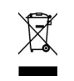
This marking indicates that this battery charger and battery pack should not be disposed
with other household wastes throughout the EU. To prevent possible harm to the
environment or human health from uncontrolled waste disposal, recycle it responsibly to
promote the sustainable reuse of material resources. To return your used device, please
use the return and collection systems or contact the retailer where the product was
purchased. They can take this product for environmental safe recycling.

Index

1.Product Introduction 3
2.Product Information and Specifications 3
3. Function and Operation Instructions 4
3.1 Function Instructions 4
3.2 Notice 7
3.3 Quick Actions 8
3.4Disassembly and cleaning of storage basket 9
3.5 Installation and removal of station feet 10
4.FAQ and Troubleshooting Guide 10
5.The Battery Power and Long-term Storage in Winter 11
6.Packing List 12
7.Warranty Information 12

Warning
- Please read the instructions carefully and follow the instructions. Our company is not responsible for any loss or injury caused by improper use.
- Only use the accessories recommended or sold by the manufacturer.
- Do not let children ride on the cleaning vehicle or use it as a toy.
- The charging adapter must be connected to the leakage protection ground socket when charging.
- Making sure the recharge socket is dry before charging.
- Only use the original authorized power adapter.
- Charging should be kept in a cool place and not covered with anything to prevent overheating from damaging internal electrical components.
- Only a qualified electrician can replace the adapter cable.
- When storing for a long time, please clean and wipe the cleaner, charge the cleaner with a charger, and store it in a cool place. It should be charge every three months to keep the battery level between 40% and 70%.Only use the original authorized power adapter. If the battery is not charged for a long time after cleaning ,the battery voltage will be lower than the discharge protection voltage due to the self-discharge of the battery, which may cause fatal damage.
- Be sure to clean the filter after use.
- Only a certified professional can remove the sealed drive kit of the cleaner.
- Due to the limitation of battery capacity, the cleaning machine is only suitable for swimming pools below 1600 SQ/FT（150㎡）, or it will affect the cleaning effect.
- Do not Pierce the shell of the cleaning machine with a needle or other sharp objects.
- This appliance contains batteries that are only replaceable by skilled persons.
- This appliance is not intended for use by persons (including children) with reduced physical, sensory or mental capabilities, or lack of experience and knowledge, unless they have been given supervision or instruction concerning use of the appliance by a person responsible for their safety.
- Children should be supervised to ensure that they do not play with the appliance.
- Pollution of the liquid could occur due to leakage of lubricants.

1.Product Introduction
This product uses the combination of lithium battery and solar charging to power the machine, while retaining the external charger fast charging mode, so that the machine can have a good battery life and emergency ability. The machine's propulsion and rolling motor are brushless electric machine which have high working efficiency and long service life. The machine has automatic obstacle avoidance and escape functions, certain maneuverability and wall-sticking effect on the water surface , so that all corners of the pool surface can be cleaned well.

2.Product Information and Specifications

Product Model | DFC/RB/F001 | Filtering Capability | 860 SQ/FT（80㎡）
Rated Voltage | 11.1V | Solar Panel Power | 10W
Power | 8W | Filtering Density | 400um
Cruising Ability | More than 6 hours | Movement Speed | 5-10 meters/minute
Rated Input Voltage of the charger | 100-240VAC | IP Code | IPX7
Rated Input Frequency of the Charger | 50/60HZ | Swimming Pool Water Temperature | 50℉-95℉(10℃-35℃)
Rated Output Voltage of the Charger | 12.6VDC | Motor Type | brushless
Rated Output Current of the Charger | 1.0A | Size | 535(U)*465(W)*180(H)MM
Battery Capacity | 2500mAh | Weight | 10.91 LB
Charge Time | 2-3 hours | Storage Temperature | -4℉~113℉（-20℃~45℃）RH≤75%
Storage capacity | 4.1L

Function and Operation Instructions

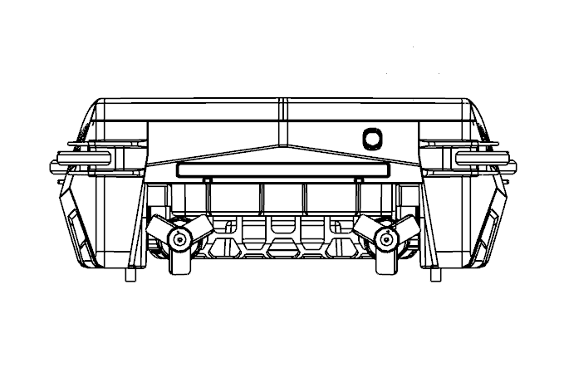
3.1 Function Instructions
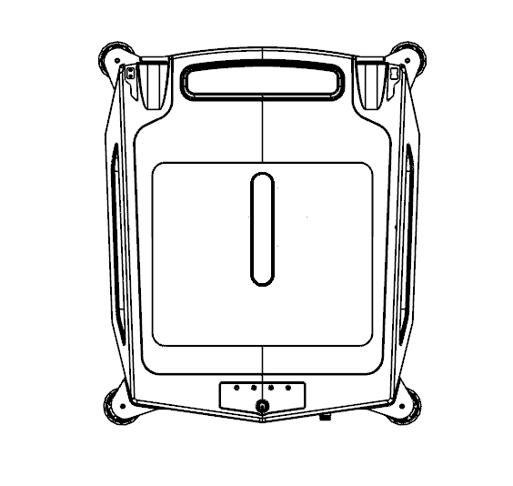  ②  ⑥  ⑤  ④  ①  ③ | ⑨  ⑩  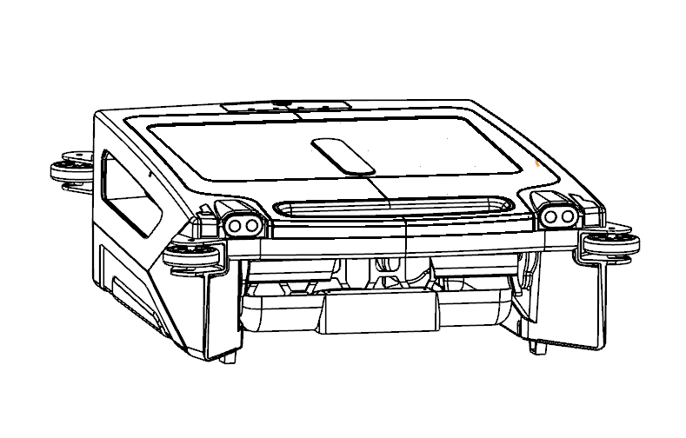  ⑪  ⑬  ⑫  ⑦  ⑧  ⑦  ⑧
①Solar panel  ②Function button (on/off)  ③Adapter charging prompt light  ④Solar charging light  ⑤Quick cleaning indicator light  ⑥Normal cleaning indicator light | ⑦Machine left and right radar  ⑧Machine left and right headlights  ⑨Tail light  ⑩Adapter charging port  ⑪Side-to-side propulsion motor  ⑫Storage baskets  ⑬Rolling brush
1.Charging prompt function
When the ⑩adapter charging port starts to charge and the battery is not full, the ③adapter charging prompt light will flash. When the battery is fully charged, the③ adapter charging prompt light will light up and beep for one minute.When the adapter is finished charging and unplugged, the machine automatically shuts down and disables the self-start function;
When the ①solar panel is in the sun, the ④solar charging prompt light will light up.

2.Power switch function
Press and hold the ② function button for 2-3 seconds. The indicator, motor, buzzer and other hardware will self-check, indicating that the cleaner enters the normal working state, and turn on the self-boot feature.
In the startup state, long press the ② function button for 2-3 seconds to shut down the cleaner.

3.Cleaning function
The ⑪ side-to-side propulsion motor and the ⑬ rolling brush will start, wherein the rolling brush will roll in a clockwise direction. The ⑧machine left and right headlights and ⑨Tail light will flash.

4.Working modes switching
Press the ② function button to switch between the quick cleaning mode and the normal cleaning mode, and the corresponding prompt light will also switch; Power on for normal cleaning mode.

5.Barrier and escape function
When the radar senses obstacles such as the pool wall, it will automatically adjust the direction of movement.
When the Robotic Pool Cleaner enters the blind zone or is trapped, it will automatically backslide and turn to escape.

6.Automatic adjustment of cleaning direction
In order to enable Robotic Pool Cleaner to clean the water surface with maximum range without dead corners, Robotic Pool Cleaner will automatically adjust the cleaning direction.

7.Self-start function
In the state of manual power on, when the solar energy is charging and the battery voltage reaches a certain value, the machine will automatically start to clean;
The self-start function closes when the machine is turned off manually or when the adapter is fully charged;

8.Fault prompt function
When the brush motor is blocked or stuck, the tail light will flash red, suggesting that the brush needs to be cleaned or overhauled;

9. Status Indicator
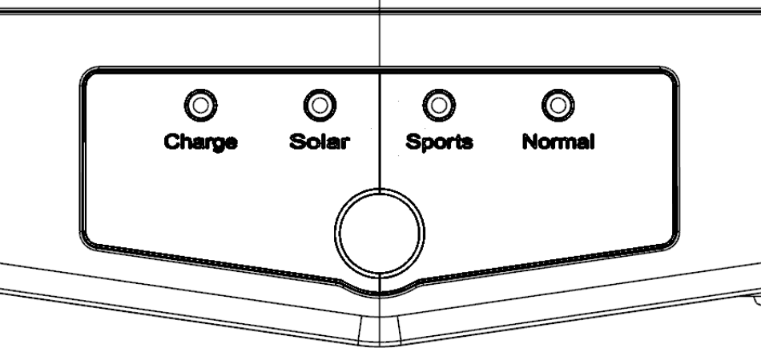
When the charger starts charging, the blue light blinks continuously ; when the battery is full, the blue light stays on.
Solar charging in standby, green light blinks slowly; green light blinks fast or long when fully charged;
Normal mode operation: green and blue light flashes when charging by sunlight; green light flashes fast or long when fully charged;
Solar green light and Sports blue light blink when working in Sports mode and solar charging; Solar green light blinks fast or long when fully charged;
The Normal blue light blinks when Normal mode is operating and there is no solar charging;
The Sports blue light blinks when Sport mode is operating and there is no solar charging;
when then machine is turned off manually all the lights go off or when the battery is low ,thus you can only turn on the machine after it has been charged sufficiently.

3.2 Notice
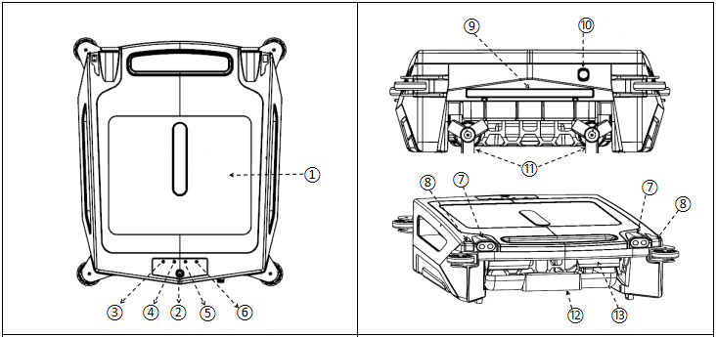

- When the Robotic Pool Cleaner is placed, pay attention to the protection of the ⑪ side-to-side propulsion motor to avoid damage or deformation of the impeller.
- Checking before starting, pay attention to the ⑪ side-to-side promotion motor and ⑬ rolling brush, whether there is stuck or foreign body entanglement which need to remove it first.
- After the adapter is charged and before working on water , pay attention to check the⑩adapter charging port first, whether screw the cover well, so as to avoid water entering the charging port and causing corrosion.
- Noting that the surface of the ①solar panel is clean, so as to ensure the best effect of solar charging.
- Pay attention to the ⑦ machine around the radar, whether there is obvious dirt on the surface which remove it first.
6.Before Robotic Pool Cleaner launching work, pay attention to install the storage basket.

3.3 Quick Actions

1.Charge: Use the supplied adapter to charge the battery.

When the ⑩ adapter charging port starts to charge, when the battery is not full, the ③adapter charging prompt light will flash.
When the battery is fully charged, the③ adapter charging prompt light will be steady on and beep for one minute.
After the adapter is charged, before working on water, pay attention to check the ⑩ adapter charging port and screw the cover, so as not to have water in the charging port to cause corrosion.

2.Turn on: Put the Robotic Pool Cleaner in the pool, long press the power switch for about 2-3 seconds, the power light flashes and the buzzer prompts.

3.Into the water: After the machine turn on, the Robotic Pool Cleaner will run automatically after 3 seconds.

4.Clean the storage basket and observe whether the garbage inside the storage basket is full by observing the observation window on the solar panel. If it is full, remove the storage basket for cleaning.

5.After cleaning, you can repeat 2-4 steps until the pool is clean.

6.When there is insufficient power to stop during the cleaning process.
Perform Steps 1-5.

7.This equipment comes with solar charging function, in normal use, such as in outdoor sunlight conditions, can not use the adapter for charging, the machine can also work normally.

3.4Disassembly and cleaning of storage basket
1.Disassembly of storage basket
 | 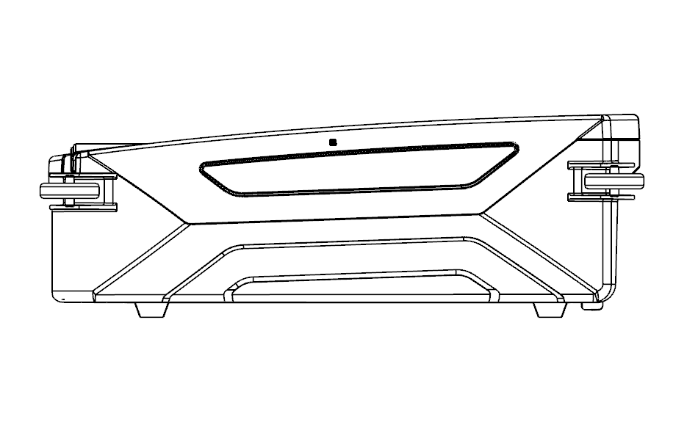
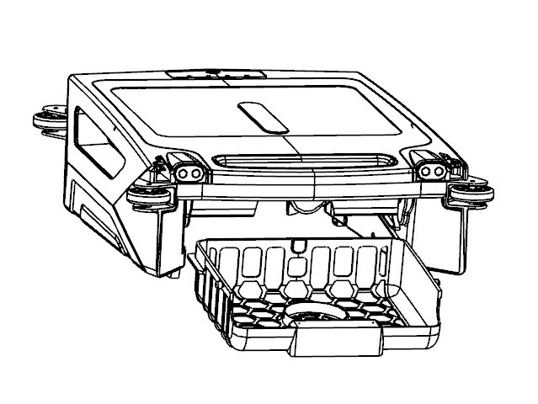 | 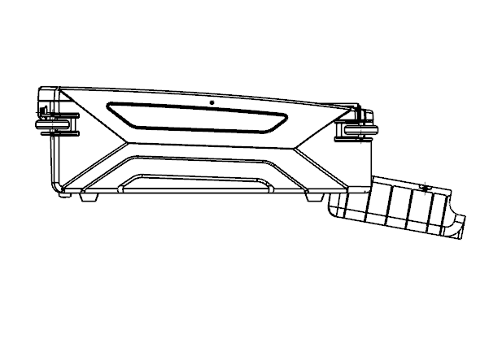
Take out the storage basket in the direction of the arrow (the installation direction is opposite to the removal direction).

- Storage basket cleaning
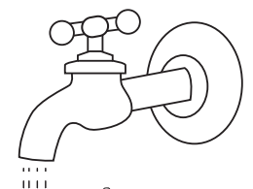

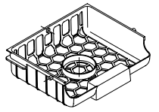

3.5 Installation and removal of stationary feet
1. Installation of the feet, as shown in the figure below
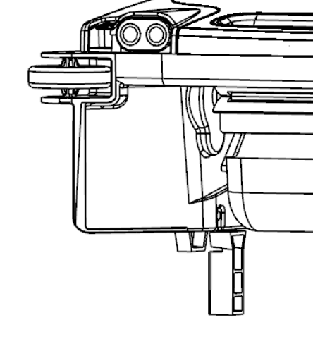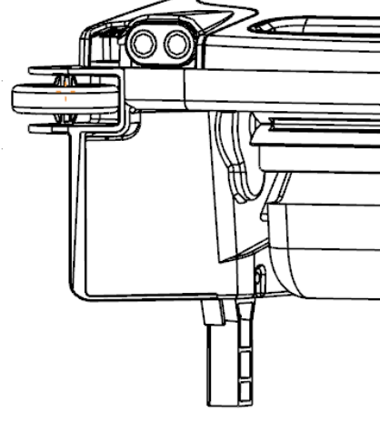
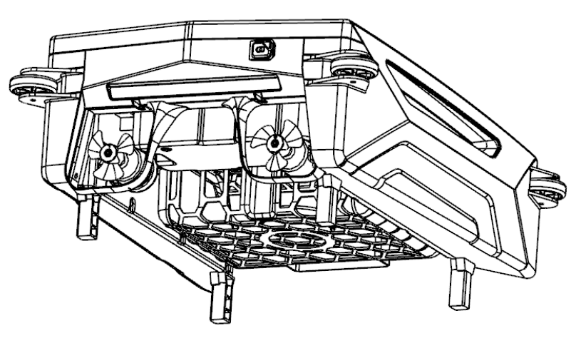
2.Standing foot removal, opposite of installation;

4.FAQ and Troubleshooting Guide
FAQ
Full battery life | Normal mode: about 12 hours or more; Sport mode: about 8 hours or more;
How long does it take for solar charging to go from standby to auto-start? | This is related to the intensity of the sunlight, usually in full sunlight, within half an hour will be able to self-start work (FYI);
How long does it take for solar charging to be fully charged? | This is related to the intensity of the sunlight. if the sunlight intensity is high and the machine is off, the machine can reach more than 85% after 6 hours of charging, and can be fully charged in about 10 hours or more (FYI);
How long does it take to be fully charged with a charger? | Can be fully charged in 2-3 hours
Troubleshooting Guide
Status | Probable Cause | Solution
No response after power-on. | The battery is not sufficient | Start with a quick charge with the charger or 1 hour in the sun.
The machine stopped working soon after turned it on. | The battery is not sufficient. | Start with a quick charge with the charger or 1 hour in the sun.
Don't work at night. | The battery is not sufficient. | Start with a quick charge with an charger.
The adapter does not respond when charging. | Long-term storage battery quantity is seriously insufficient. | Waiting a few to ten minutes, let the battery power slowly increase before there will be a reaction.
The rolling brush does not turn. | There could be something stuck. | Cleaning up foreign objects.
The propulsion motor does not rotate. | There could be something stuck. | Cleaning up foreign objects.
Continuous spin. | Any foreign objects on the radar. | Cleaning up foreign objects.
 | There may be something stuck in the propulsion motor. | Cleaning up foreign objects.

5.The Battery Power and Long-term Storage in Winter
Battery power in winter
In the winter, many batteries are not fully charged due to the sun's rays are not that strong. You should expect Robotic Pool Cleaner to run shorter than in the summer. Even if you live in a sunny climate, such as California, Florida, or AstraZeneca, you may not be able to fully charge, or you may need to charge for a longer period of time, and you may need to rely more on an external adapter to replenish the charge and extend the use time.

Long-term storage indoors
Please clean the Robotic Pool Cleaner. It should be recharged every three months to keep the battery charge between 40%-70%,. please only use the original authorized power adapter. If the cleaning is not charged for a long time, due to the self-discharge of the battery, the battery voltage will be lower than the discharge protection voltage, which may cause fatal damage.

6.Packing List
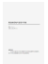
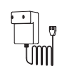
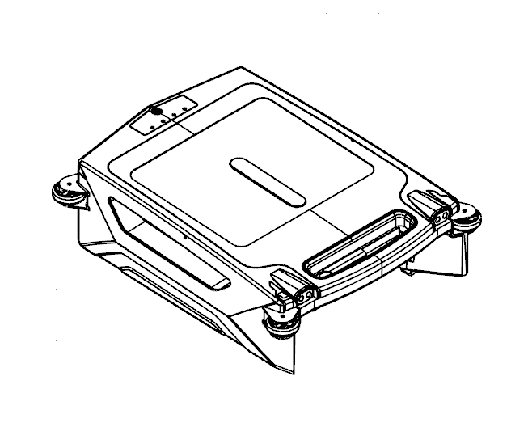

No. | Name | Model | Quantity | Remark
1 | Robotic Pool Cleaner | DFC/RB/F001 | 1 | In Carton
2 | Battery Charger |  | 1 | In Carton
3 | Storage Baskets |  | 1 | In Machine
4 | User Manual |  | 1 | In Plastic Bags
5 | Guarantee card |  | 1 | In Carton
6 | Certification |  | 1 | In Carton

7.Warranty Information
This product has undergone all quality control and safety tests by the factory production department;
Warranty Information:
1. The warranty period is 12 months (battery and motor only) from the date of original purchase.
2. This warranty is void if the product is modified, misused or repaired by unauthorized personnel.
3. The warranty only extends to manufacturing defects and thus does not cover any damage caused by the owner's improper operation of the product.
4. Sales invoices must be presented for any claims or repairs made during the warranty period.
5. Any warranty problem, please contact our customer service.


